The Path to the Periodic Table: Building the Periodic Table
Web Help: http://www.chemheritage.org/classroom/chemach/periodic/index.html
Introduction and Historical Context
Sodium acts a lot like potassium. Silver acts a lot like gold. For a long time scientists have
known that elements seem to be grouped into families with common properties. However, just
which elements belonged together took some time to figure out. Around 1870 two scientists
determined a way to order the elements. Dmitri Mendeleev (below, left) and Julius Lothar Meyer both came up with periodic tables that showed how the elements should be grouped.
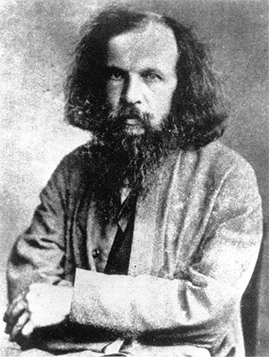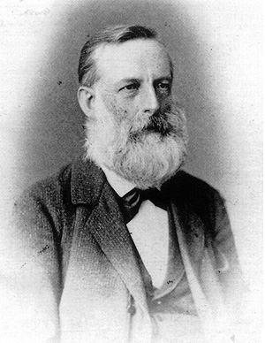

Meyer lived and worked in Germany, while Mendeleev lived and worked in Russia. Both
scientists were teachers. They hoped that if they could arrange the elements in some way that
made sense, it would be easier for students to learn about all the elements and their properties.
Meyer and Mendeleev worked separately, and neither one knew that the other was working on
a periodic table. Even so, the tables they came up with separately were very similar. The
periodic table we use today is based on the ones they created.

In this activity you’re going to walk in the footsteps of Meyer and Mendeleev. You will be given
cards with the names and properties of elements, and you will be asked to group the different
elements together in a way that makes sense to you.
Purpose
You will learn how the elements are grouped in the periodic table and what kinds of information
you can obtain by reading the periodic table.
Safety
This activity presents no safety hazards except those of you that are allergic to using your brain.
Materials and apparatus
Element cards provided by your instructor and your lab notebook to record your decisions and observations.

Pre-Lab Questions (answer in your lab notebook)
1. What is an element? How many different kinds of atom is any element made of?
2. Do all elements/atoms combine the same way?
3. What types of materials have similar properties? (Ex: shiny matter (metals) tends to conduct electricity)
4. How many atoms of each element are present in molecules of the following compounds? Write your answer as a ratio (H₂O – 2 hydrogen : 1 oxygen).
a. HCl
b. H2O
c. CH4
d. NH3
e. CCl₄
f. H₂S
g. MgO
h. MgCl₂
i. NaCl
j. Mg₃N₂

Procedure
ATTENTION! It is not within the essence of this activity to refer to a modern version of the periodic table for help. Any attempt to cheat is considered an act of contempt punishable by mockery and firing squad. You will have brought shame upon your family for generations. It is just not worth it.

Part 1 Read all of part 1 including the analysis questions before obtaining your cards.
In this activity you will work with a partner if you wish. Your teacher will give each team a
set of cards. Each card in the set will contain information about an element. Your challenge will
be to arrange the cards into a two-dimensional grid (length and width) in some way that makes sense to you. Look for properties that are similar between elements or that have an “order” or progression. When you have finished arranging your elements, be prepared to explain to the class why you arranged the element cards the way you did. You should write your explanation down.

Diagram: Please draw your table in your lab notebook. If it has a starting point and an ending point please indicate where they are and how your table should be read.

Part 1 Analysis Questions Answer all questions in your lab notebook.
1. How did you organize your table?
2. How many groups or families of elements (sharing similar properties as shown on the card) are in your table? What criteria did you use to choose which group or family an element belongs to?
3. Is there a trend in atomic mass going across your table? Is there a trend in atomic mass
going from top to bottom?
4. Are there any exceptions to these trends? If so, which elements break the trend? Why did
you arrange these elements the way you did?
5. Are there any holes or gaps in your arrangement? Where are they? What do you think these
gaps might mean?
6. Is there a repeatable pattern that might allow you to predict the properties of “undiscovered” elements?

Part 2
Here is a quote by Friedrich Beilstein, a colleague of Mendeleev (who didn’t like the Russian very much):
“Mendeleev . . . has prophesied the existence of all sorts of new elements and believes
that he needs only to conceive of them in order to have them immediately in the bag. . . .
He is in general an odd chap.” (This was a tremendous insult back in the day)

Perhaps Mendeleev came back with Перейти к дьяволу (pere iti k’dyavoloo)! Or more informally
К Чорту (k’chortu)!

However, such evidence came in 1875. The French chemist Paul-Emile Lecoq de Boisbaudran discovered a new element he named gallium. Later, in 1886 a German chemist named Clemens Winkler discovered an element he called germanium.

Obtain the second set of cards and see where they fit into your table. Be able to defend your decision. Record your decision in your lab notebook. Add these new elements to your diagram.

Part 3
Obtain the third set of cards and determine where they should fit into your table. Be able to defend your position. Record your decision in your lab notebook. Add these new elements to your diagram.

Part 3 Analysis Questions
1. After you prepared your periodic tables, you received additional sets of cards to fit
into your tables. How did your table change each time you added new elements to your
table?
2. How is your table similar to a modern periodic table? How is yours different?
3. How do we explain today the fact that tellurium comes before iodine in the periodic table,
even though tellurium has a higher atomic mass than iodine?
4. Mendeleev predicted the existence of gallium and germanium because of the holes in his
periodic table. Why do you think Mendeleev did not predict the existence of the noble
gases?
5. Look at a modern periodic table. Suppose two new elements were discovered with the
atomic numbers 120 and 121. Where in the periodic table do you think we would place
these new elements?
6. Suppose a new element X is discovered. It forms a compound with chlorine, and the formula
of this compound is XCl4. What group or family do you think this element would belong to?
7. Find the element barium (Ba) on a modern periodic table. What group or family is barium in?
What do you think the formula of a compound of barium and chlorine would be?
8. Use the modern periodic table to help you with the following tasks:
a. Find the elements cesium (Cs), thallium (Tl), radium (Ra), and radon (Rn) on the periodic
table. Which groups are each of these elements in? What would you expect the formulas
to be for compounds of each of these elements with chlorine?
Cs:
Tl:
Ra:
Rn:

b. Suppose four new elements A, D, E, and G are discovered. Each new element forms a
compound with oxygen. The formulas for the new compounds are AO, D2O3, E2O, and
GO2. What groups or families do you think each of these elements would belong to?
A:
D:
E:
G:

